## **Running and visualising nesterov accelerated gradient descent**

Let’s execute the code for this

1. Here is the Python code for NAG, it is an improvement on the MGD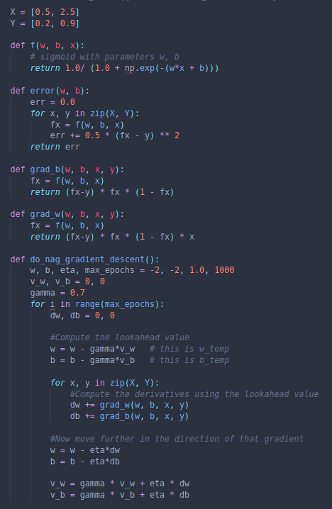
2. Here we have a comparison between NAG and MGD